Via the ArgoCD UI
- Click + NEW APP on the Applications page.
- Fill in General:
Field | Value
Field | Value
Application Name | nginx-app
Project | nginx-project
Sync Policy | Automated
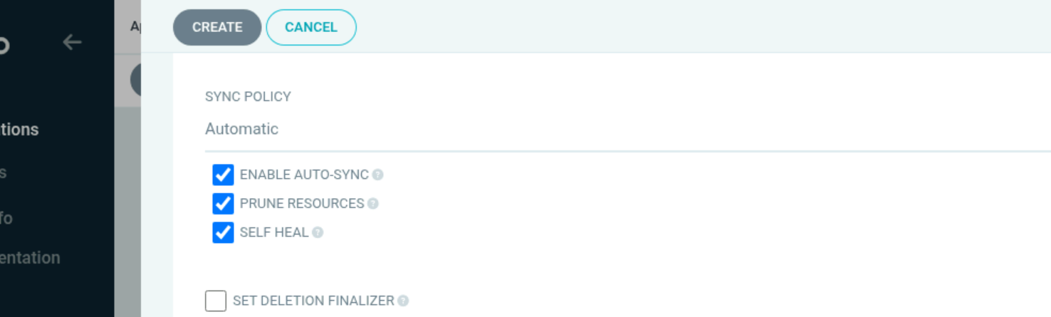

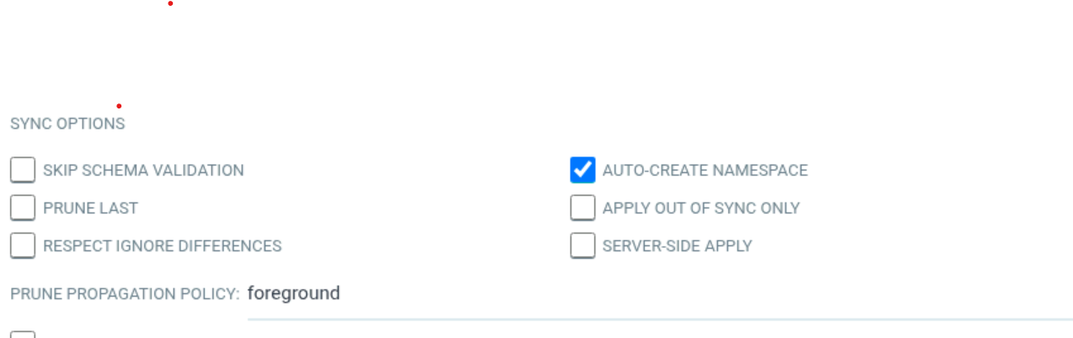

- Fill in Source:
Field | Value
Field | Value
Repository URL | https://github.com/<your-username>/nginx-argoproj.git
Revision | main (or master — match your default branch)
Path | nginx-conf
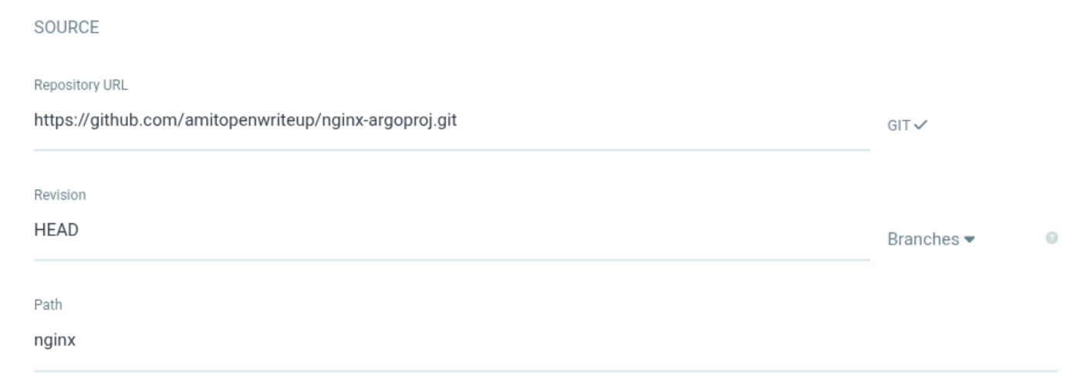
- Fill in Destination:
Field | Value
Field | Value
Cluster | https://kubernetes.default.svc
Namespace | Leave it blank
- Click Create. The application card will appear — it may show Out of Sync if auto-sync is off.
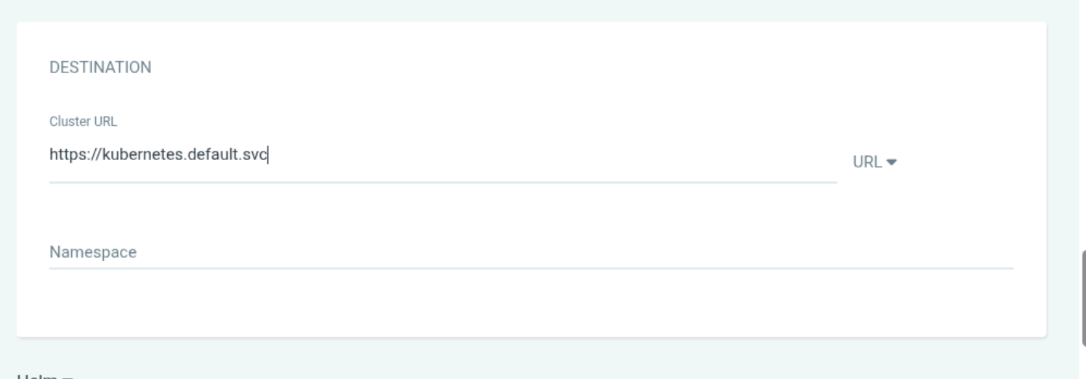
7.2 Sync the Application
Click Sync on the application card (or inside the app detail view). ArgoCD will pull the manifests from GitHub, render them, and apply them to the cluster.

